PRODUCT INVENTORY MANAGEMENT SYSTEM

TEAM LEADER : PRIYADHARSHINI D

TEAM MEMBER 1: SOUNDARYA S V

TEAM MEMBER 2: MAYHAK AISHETHA R

TEAM MEMBER 3: MUBASSHIRA FATHIMA M

Introduction :

Inventory management is an important part of any business that deals with products.
Managing products manually can lead to errors and confusion.
The Product Inventory Management System provides a digital solution to store, manage, and update product information easily.
This system allows users to add products, update stock details, and track available inventory in real time.

PROJECT OVERVIEW

The Product Inventory Management System is a backend-focused web application developed using Node.js, Express.js, and MongoDB, designed to provide a secure and scalable solution for managing product data through RESTful APIs. The system enables users to create accounts, log in securely, and access protected routes using JWT-based authentication, ensuring that only authorized users can perform operations. It supports complete CRUD functionality, allowing users to add new products, view their inventory, update product details such as price or quantity, and delete items when needed.

Key Objectives:

• Provide secure JWT-based user authentication and authorization for protected API access.
• Enable efficient product inventory management through RESTful CRUD operations.
• Ensure user-specific data isolation so each user can manage only their own products.
• Implement scalable backend architecture using Node.js, Express.js, and MongoDB.
• Deliver fast and reliable API responses with proper validation and error handling.

Problem Statement

Many small businesses still manage their inventory using notebooks or spreadsheets.

This manual method can cause problems such as data loss, incorrect stock records, and difficulty in tracking products.

The Product Inventory Management System solves these problems by providing a computerized system to store and manage product information efficiently.

Objectives of the Project

To reduce manual work in managing inventory

To track product stock easily

To update product

The main objectives of this project are:

To maintain product details in a systematic way information quickly.

To improve accuracy in inventory

PRE-REQUISITES

Software | Purpose
Node.js | JavaScript runtime for backend
MongoDB | Database storage
npm | Package manager
VS Code | Development environment

Project Thumbnail:

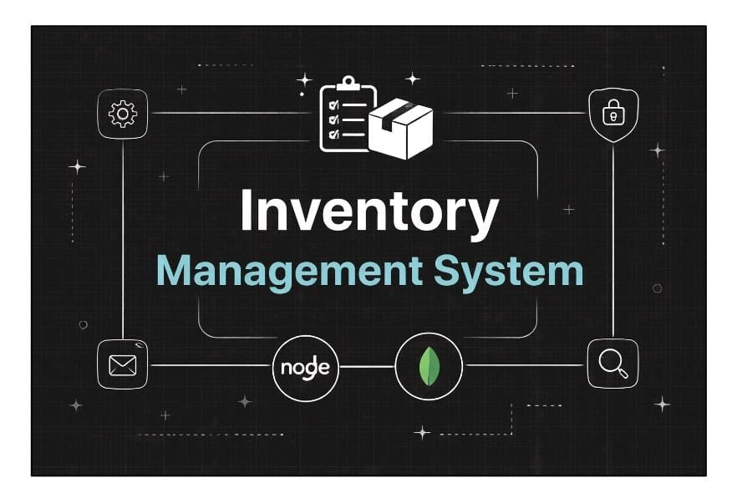

Roles and Responsibility

User
Registration: Register using name, email and password.
Login: Login using registered credentials.
Add Product: Create product with name, price, quantity and description.
Edit Product: Update existing product.
Delete Product: Remove product from inventory.
Search Product: Search products using keyword.

User Flow
- The user sends a register/login request.
- The backend generates a JWT token.
- The user sends a token in the Authorization header.
- Middleware verifies the token.
- The controller performs CRUD operations.
- MongoDB stores or retrieves product data.
Code
{
"name": "nm-backend-project",
"version": "1.0.0",
"lockfileVersion": 3,
"requires": true,
"packages": {
"node_modules/@mongodb-js/saslprep": {
"version": "1.4.6",
"resolved": "https://registry.npmjs.org/@mongodb-js/saslprep/-/saslprep-1.4.6.tgz",
"integrity": "sha512-y+x3H1xBZd38n10NZF/rEBlvDOOMQ6LKUTHqr8R9VkJ+mmQOYtJFxIlkkK8fZrtOiL6VixbOBWMbZGBdal3Z1g==",
"license": "MIT",
"dependencies": {
"sparse-bitfield": "^3.0.3"
}
},
"node_modules/@types/webidl-conversions": {
"version": "7.0.3",
"resolved": "https://registry.npmjs.org/@types/webidl-conversions/-/webidl-conversions-7.0.3.tgz",
"integrity": "sha512-CiJJvcRtIgzadHCYXw7dqEnMNRjhGZlYK05Mj9OyktqV8uVT8fD2BFOB7S1uwBE3Kj2Z+4UyPmFw/Ixgw/LAlA==",
"license": "MIT"
},
"node_modules/@typewebidl-conversions": {
"version": "7.0.3",
"resolved": "https://registry.npmjs.org/@types/webidl-conversions/-/webidl-conversions-7.0.3.tgz",
"integrity": "sha512-CiJJvcRtIgzadHCYXw7dqEnMNRjhGZlYK05Mj9OyktqV8uVT8fD2BFOB7S1uwBE3Kj2Z+4UyPmFw/Ixgw/LAlA==",

"node_modules/bcryptjs": {
"version": "3.0.3",
"resolved": "https://registry.npmjs.org/bcryptjs/-/bcryptjs-3.0.3.tgz",
"integrity": "sha512-GlF5wPWnSa/X5LKM1o0wz0suXIINz1iHRLvTS+sLyi7XPbe5ycmYI3DlZqVGZZtDgl4DmasFg7gOB3JYbphV5g==",
"license": "BSD-3-Clause",
"bin": {
"bcrypt": "bin/bcrypt"
}
},
"node_modules/binary-extensions": {
"version": "2.3.0",
"resolved": "https://registry.npmjs.org/binary-extensions/-/binary-extensions-2.3.0.tgz",
"integrity": "sha512-Ceh+7ox5qe7LJuLHoY0feh3pHuUDHAcRUeyL2VYghZwfpkNIy/+8Ocg0a3UuSoYzavmylwuLWQOf3hl0jjMMIw==",
"dev": true,
"license": "MIT",
"engines": {
"node": ">=8"
},
"funding": {
"url": "https://github.com/sponsors/sindresorhus"
}
},
"node_modules/body-parser": {
"version": "2.2.2",
"resolved": "https://registry.npmjs.org/body-parser/-/body-parser-2.2.2.tgz",
"integrity": "sha512-oP5VkATKlNwcgvxi0vM0p/D3n2C3EReYVX+DNYs5TjZFn/oQt2j+4sVJtSMr18pdRr8wjTcBl6LoV+FUwzPmNA==",
"license": "MIT",
"dependencies": {
"bytes": "^3.1.2",
"content-type": "^1.0.5",
"debug": "^4.4.3",
"http-errors
"type-is": "^2.0.1"
},
"engines": {
"node": ">=18"
},
"node_modules/ecdsa-sig-formatter": {
"version": "1.0.11",
"resolved": "https://registry.npmjs.org/ecdsa-sig-formatter/-/ecdsa-sig-formatter-1.0.11.tgz",
"integrity": "sha512-nagl3RYrbNv6kQkeJIpt6NJZy8twLB/2vtz6yN9Z4vRKHN4/QZJIEbqohALSgwKdnksuY3k5Addp5lg8sVoVcQ==",
"license": "Apache-2.0",
"dependencies": {
"safe-buffer": "^5.0.1"
}
},
"node_modules/ee-first": {
"version": "1.1.1",
"resolved": "https://registry.npmjs.org/ee-first/-/ee-first-1.1.1.tgz",
"integrity": "sha512-WMwm9LhRUo+WUaRN+vRuETqG89IgZphVSNkdFgeb6sS/E4OrDIN7t48CAewSHXc6C8lefD8KKfr5vY61brQlow==",
"license": "MIT"
},
"node_modules/encodeurl": {
"version": "2.0.0",
"resolved": "https://registry.npmjs.org/encodeurl/-/encodeurl-2.0.0.tgz",
"integrity": "sha512-Q0n9HRi4m6JuGIV1eFlmvJB7ZEVxu93IrMyiMsGC0lrMJMWzRgx6WGquyfQgZVb31vhGgXnfmPNNXmxnOkRBrg==",
"license": "MIT",
"engines": {
"node": ">= 0.8"
}
},
"node_modules/es-define-property": {
"version": "1.0.1",
"resolved": "https://registry.npmjs.org/es-define-property/-/es-define-property-1.0.1.tgz",
"integrity": "sha512-e3nRfgfUZ4rNGL232gUgX06QNyyez04KdjFrF+LTRoOXmrOgFKDg4BCdsjW8EnT69eqdYGmRpJwiPVYNrCaW3g==",
"license": "MIT",
"engines": {
"node": ">= 0.4"
}
},
"node_modules/es-errors": {
"version": "1.3.0",
"resolved": "https://registry.npmjs.org/es-errors/-/es-errors-1.3.0.tgz",
"integrity": "sha512-Zf5H2Kxt2xjTvbJvP2ZWLEICxA6j+hAmMzIlypy4xcBg1vKVnx89Wy0GbS+kf5cwCVFFzdCFh2XSCFNULS6csw==",
"license": "MIT",
"engines": {
"node": ">= 0.4"
}
},
"node_modules/es-object-atoms": {
"version": "1.1.1",
"resolved": "https://registry.npmjs.org/es-object-atoms/-/es-object-atoms-1.1.1.tgz",
"integrity": "sha512-FGgH2h8zKNim9ljj7dankFPcICIK9Cp5bm+c2gQSYePhpaG5+esrLODihIorn+Pe6FGJzWhXQotPv73jTaldXA==",
"license": "MIT",
"dependencies": {
"es-errors": "^1.3.0"
},
"engines": {
"node": ">= 0.4"
}
},
"node_modules/escape-html": {
"version": "1.0.3",
"resolved": "https://registry.npmjs.org/escape-html/-/escape-html-1.0.3.tgz",
"integrity": "sha512-NiSupZ4OeuGwr68lGIeym/ksIZMJodUGOSCZ/FSnTxcrekbvqrgdUxlJOMpijaKZVjAJrWrGs/6Jy8OMuyj9ow==",
"license": "MIT"
},
"node_modules/etag": {
"version": "1.8.1",
"resolved": "https://registry.npmjs.org/etag/-/etag-1.8.1.tgz",
"integrity": "sha512-aIL5Fx7mawVa300al2BnEE4iNvo1qETxLrPI/o05L7z6go7fCw1J6EQmbK4FmJ2AS7kgVF/KEZWufBfdClMcPg==",
"license": "MIT",
"engines": {
"node": ">= 0.6"
}
},
"node_modules/express": {
"version": "5.2.1",
"resolved": "https://registry.npmjs.org/express/-/express-5.2.1.tgz",
"integrity": "sha512-hIS4idWWai69NezIdRt2xFVofaF4j+6INOpJlVOLDO8zXGpUVEVzIYk12UUi2JzjEzWL3IOAxcTubgz9Po0yXw==",
"license": "MIT",
"dependencies": {
"accepts": "^2.0.0",
"body-parser": "^2.2.1",
"content-disposition": "^1.0.0",
"content-type": "^1.0.5",
"cookie": "^0.7.1",
"cookie-signature": "^1.2.1",
"debug": "^4.4.0",
"depd": "^2.0.0",
"encodeurl": "^2.0.0",
"escape-html": "^1.0.3",
"etag": "^1.8.1",
"finalhandler": "^2.1.0",
"fresh": "^2.0.0",
"http-errors": "^2.0.0",
"merge-descriptors": "^2.0.0",
"mime-types": "^3.0.0",
"on-finished": "^2.4.1",
"once": "^1.4.0",
"parseurl": "^1.3.3",
"proxy-addr": "^2.0.7",
"qs": "^6.14.0",
"range-parser": "^1.2.1",
"router": "^2.2.0",
"send": "^1.1.0",
"serve-static": "^2.2.0",
"statuses": "^2.0.1",
"type-is": "^2.0.1",
"vary": "^1.1.2"
},
"engines": {
"node": ">= 18"
},
"funding": {
"type": "opencollective",
"url": "https://opencollective.com/express"
}

DEMO LINK:
https://drive.google.com/file/d/1G5YmD2FRUjh9j9l0HMGajYvxAPvtWF6g/view?usp=drivesdk

code link
https://drive.google.com/drive/folders/1Dkmn7AD5oJzkwW4bDzH-lf1hCxHzjTUk?usp=drive_link

